**Weblogic and MQ communication via Foreign Server:**

**Foreign Server Destination config:-**

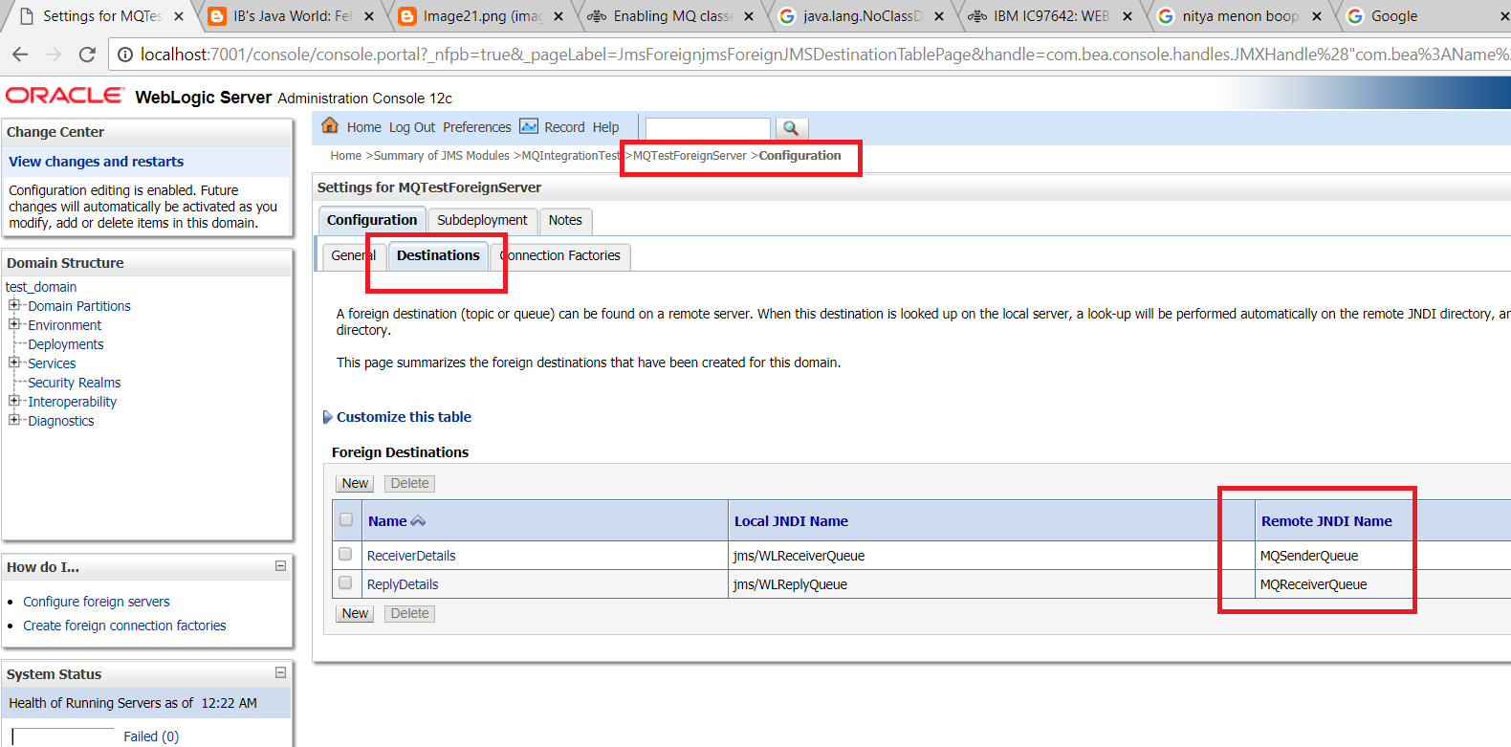

**MQ broker configuration:-**

Created two Queue’s:

1. MQReceiveQueue(Read/listening MDB responding message)
2. MQSendingQueue(Sending message to MDB)

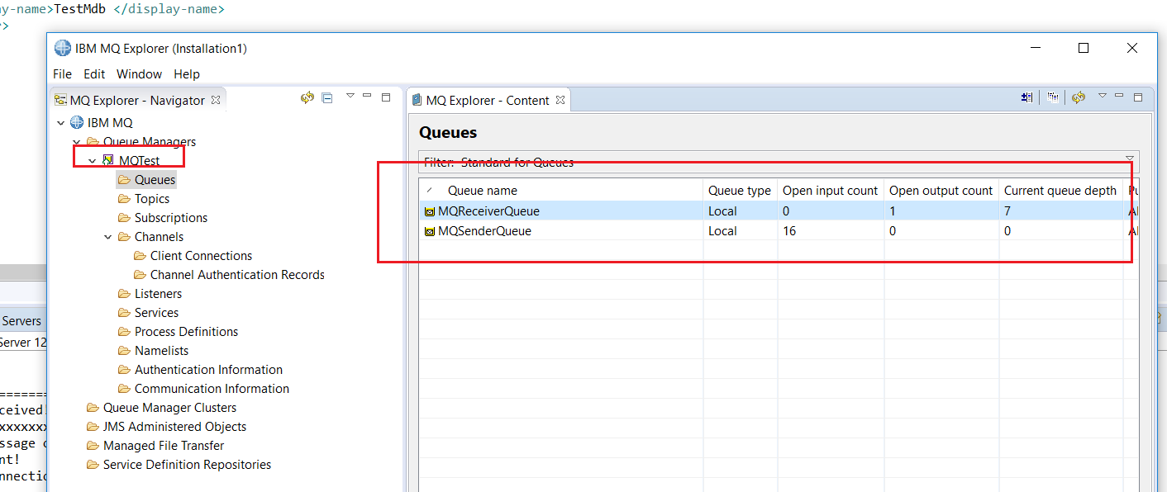

Testing Steps:-

1. **Sending message from Broker/putting message in to Destination queue :**

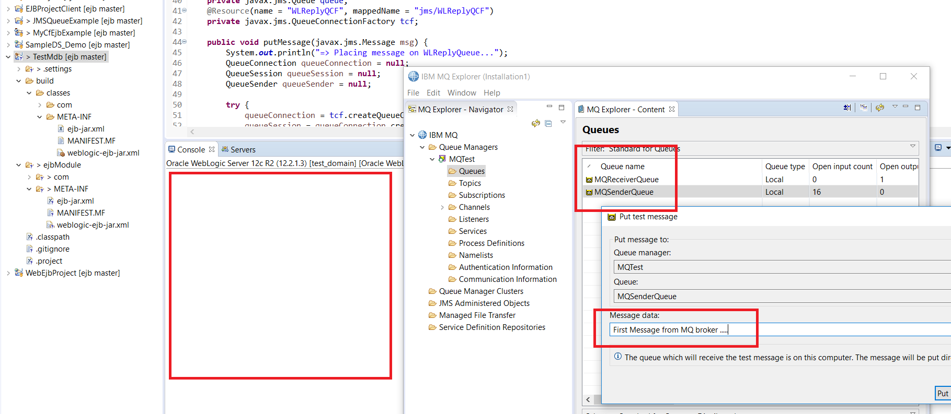

1. **MDB will receiving the message :-**

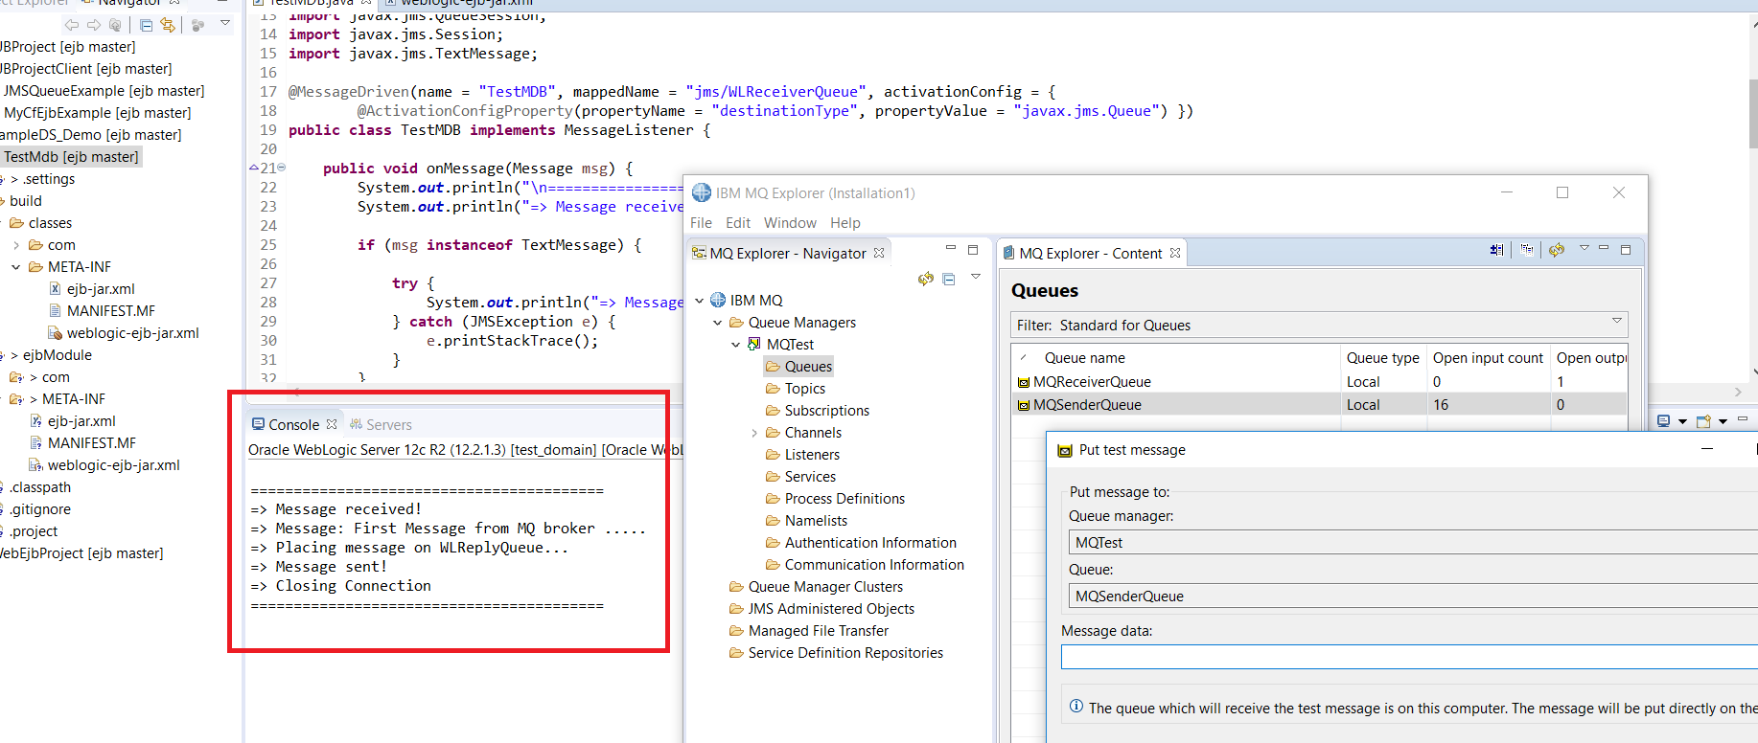

1. **MDB again responding to Foreign Queue(ReceiverQ):**

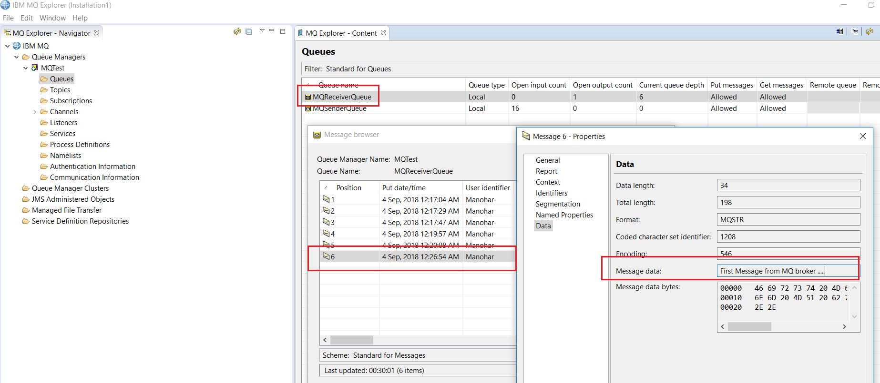

1. **Sample MDB Code snippet :**

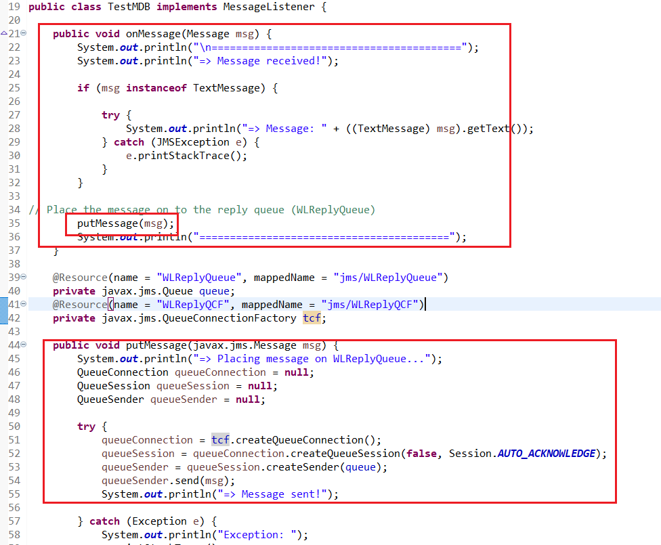

1. **Sample MDB and binding file source code:**





1. **Lib need to be copied in to weblogic domain.**

com.ibm.dhbcore.jar

com.ibm.mq.commonservices.jar

com.ibm.mq.jar

com.ibm.mq.jmqi.jar

com.ibm.mqjms.jar

fscontext.jar

sun-jndi-providerutil.jar